
INTERNATIONAL OFFICE
INTERNSHIP STUDENT LOGBOOK




INDUSTRIAL TRAINING
LOG BOOK

Name | :  Putrajaya Campus, Jalan ikram-uniten,43000 kajang, Selangor, Malaysia | Zakaria MAKHROUB
Programme | : | Mobility international program
Home University | : | EMINES – UM6P
Attachment Unit | : | IICE
Supervisor | : | Dr Khairi AZIZ

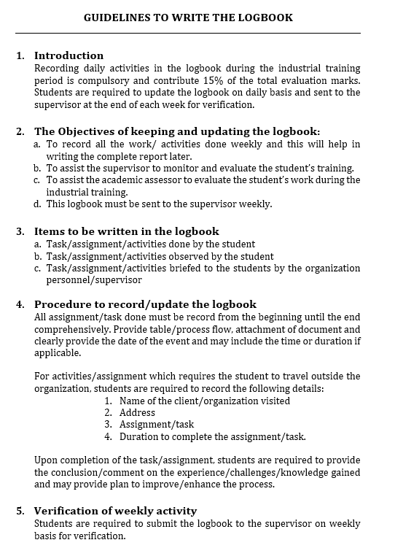

WEEKLY REPORTS

WEEK 1
DATE | TASK | SUPERVISOR’S REMARKS
22/6/26  -  24/6/26 | - Reviewed the GRIDPREDICT proposal and the Agentic AI Grant Pitching Deck to gain an understanding of the Agentic AI framework and predictive maintenance objectives.  - Read more about the project and attended a meeting with my supervisor.
25/6/26  26/6/26 | - Started searching for a suitable dataset for the project, identified a promising candidate, and am currently awaiting my supervisor's approval.
SUPERVISOR’S SIGNATURE

Sketching page
WEEK 2
DATE | TASK | SUPERVISOR’S REMARKS
29/06/2026 -  01/07/26 | - Tried to understand the role of the agents, how they work, and designed an initial architecture.  - Studied how the data will enter the system and how the agents will communicate with each other.
02/07/2026 | - Sent the proposed architecture to my supervisor and am waiting for approval.
03/07/2026 | - Started preparing the dataset for the project.
SUPERVISOR’S SIGNATURE

Sketching page
WEEK 3
DATE | TASK | SUPERVISOR’S REMARKS
SUPERVISOR’S SIGNATURE

Sketching page
WEEK 4
DATE | TASK | SUPERVISOR’S REMARKS
SUPERVISOR’S SIGNATURE

Sketching page
WEEK 5
DATE | TASK | SUPERVISOR’S REMARKS
SUPERVISOR’S SIGNATURE

Sketching page
WEEK 6
DATE | TASK | SUPERVISOR’S REMARKS
SUPERVISOR’S SIGNATURE

Sketching page
WEEK 7
DATE | TASK | SUPERVISOR’S REMARKS
SUPERVISOR’S SIGNATURE

Sketching page
WEEK 8
DATE | TASK | SUPERVISOR’S REMARKS
SUPERVISOR’S SIGNATURE

Sketching page

WEEK 9
DATE | TASK | SUPERVISOR’S REMARKS
SUPERVISOR’S SIGNATURE

Sketching page
WEEK 10
DATE | TASK | SUPERVISOR’S REMARKS
SUPERVISOR’S SIGNATURE

Sketching page
WEEK 11
DATE | TASK | SUPERVISOR’S REMARKS
SUPERVISOR’S SIGNATURE

Sketching page
WEEK 12
DATE | TASK | SUPERVISOR’S REMARKS
SUPERVISOR’S SIGNATURE

Sketching page

Final Grading Form
(To be filled by the Supervisor)
ITEMS | MARKS | REMARKS
Host Supervisor Evaluation | / 25
Assessment of the Prototype / Research prepared by the Student | / 25
Assessment of the Report prepared by the Student | / 25
Logbook Evaluation | / 25

TOTAL MARKS = / 100%
GRADING = PASS / FAIL

Verified by Host University Representative,

__________________________+
( )

Verified by Home University Representative,

__________________________+
( )

